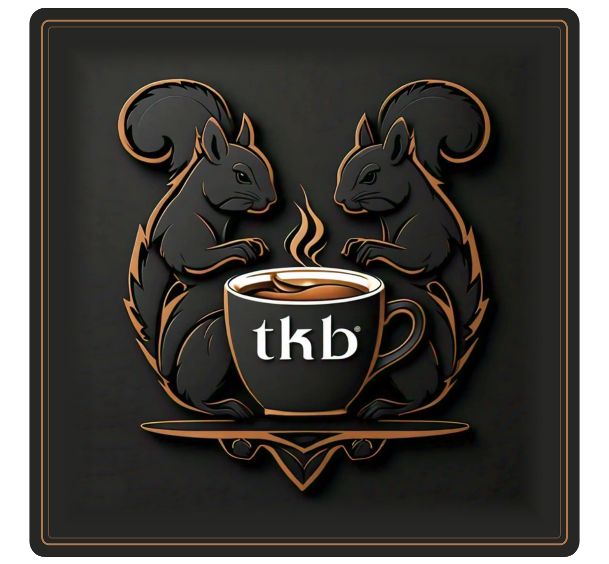
TKB Diner
Breakfast · Lunch · Dinner
814 Broadway · Marysville, KS 66508
(785) 562-3354
Join us on Facebook

TKB Diner
Classic Breakfast
Favorites  Biscuits & Gravy half 4 · full 7  Biscuits and homemade sausage gravy  Breakfast Sandwich 8  Choice of ham, bacon or sausage, cheese and one egg  Breakfast Burrito 9  Choice of meat, cheddar and two eggs  Western Burrito 11  Ham, cheddar, potatoes, onions, peppers and two eggs  Breakfast Bowl 10  Hashbrowns, ham, bacon, sausage, cheese, veggies and two eggs  Stacked Hashbrowns 11  Ham, bacon, sausage, cheese, veggies and two eggs  From the Griddle  French Toast half 5 · full 10  Dusted with powdered sugar, side of syrup · add blueberries +1  Pancakes 1 for 2 · 3 for 5 · 6 for 8  Single, short stack or full stack  Oatmeal 6  Served with brown sugar, craisins and pecans |  | 3-Egg Omelettes  Served with your choice of toast  Denver 12  Ham, cheddar, onions and peppers  Garden 11  All the veggies and cheese  Meat & Cheese 12  Ham, bacon and sausage  Breakfast Plates  One Eyed Jack 5  One egg and toast  Hobo 6  Two eggs and toast  Bird's Nest 9  One egg, choice of meat and toast  Bullseye 10  Two eggs, choice of meat and toast  Sides & Extras  Hashbrowns 3  Toast 3  Sausage gravy 3  Biscuit 2  Ham, bacon or sausage 4  Egg 2  Cheese 2  Onion, pepper, jalapeño 1
TKB Diner
Appetizers & Sandwiches
Appetizers
Sampler — pick any 3 13

Corn Nuggets 8 |  | Onion Rings 9
Pickle Chips 8 |  | Mozzarella Sticks 9
Cheeseballs 9 |  | Jalapeño Bites 9
Spinach Artichoke Dip 9 |  | Broccoli & Cheese Bites 9
Mac & Cheese Wedges 9 |  | French Fries 7
Sweet Potato Fries 8
Sandwiches
Served with fries · substitute any side +2
Deli Classics  BLT half 9 · full 11  Wheat, bacon, lettuce, tomato, mayo  Reuben half 10 · full 12  Rye, corned beef, 1000 Island, sauerkraut, Swiss  Rachel half 10 · full 12  Rye, turkey, 1000 Island, sauerkraut, Swiss  Club half 10 · full 12  Sourdough, turkey, bacon, tomato, ranch, Colby jack |  | Hot Sandwiches · 13  On a bun with mayo; lettuce, tomato and onion on the side  Grilled Chicken 13  Philly 13  Hoagie bun, peppers, onions, Swiss
  Hand-Breaded to Order
  Breaded by hand in our kitchen and fried crisp and golden the moment you order.
  Pork Tender 13
  Chicken Fried Chicken 13
  Country Fried Steak 13
TKB Diner
Burgers & Baskets
Burgers
Served with fries · substitute any side +2
Add Cheese +1 Peppers or jalapeños +1 Bacon +2 Extra patty +3
The Black Squirrel 14
Bacon jam, muenster & gouda, Nutella

Plain Jane 12  Just the burger patty |  | Patty Melt 13  Rye, 1000 Island, Swiss
The Whiskey 14  Swiss, cheddar, bacon, onion tanglers, whiskey sauce |  | The Sunrise 14  Cheddar, bacon, fried egg
The Firehouse 14  Pepper jack, bacon, jalapeño, sriracha mayo |  | The Midwest 14  Colby jack, onion ring, BBQ sauce
TKB Melt 14  Swiss, grilled peppers, onions and mushrooms, garlic aioli |  | The Club 14  Colby jack, turkey, bacon, tomato, ranch
The Carter 14  Cheddar & Swiss, onion tanglers, bacon, fried egg, ranch |  | The Reuben Burger 14  Swiss, corned beef, sauerkraut, 1000 Island
Baskets & Wraps
Fish & Chips 14  8 oz walleye strips and fries |  | Chicken Strips 14  Hand-breaded to order · 4 chicken strips and fries
Shrimp 15  8 butterfly shrimp and fries |  | CBR Wrap 12  Crispy or grilled chicken, bacon, ranch, cheese, lettuce, tomato
Swap your fries (+2): veggie of the day, baked potato, loaded baked potato, sweet potato fries, mashed potatoes & gravy, side salad, seasonal salad, cup of soup or an appetizer
TKB Diner
Entrees, Soup & Salads
Entrees  Served with your choice of two sides and a dinner roll  Steak Bites ½ lb 18 · 1 lb 23  Hamburger Steak 17  Sautéed mushrooms and onions optional  Grilled Chicken 17  12 oz KC Strip 26 |  | Homemade Soup  Seasonal — today's soups are posted on the specials board  Cup 4  Bowl 6  Salads  Chef half 9 · full 12  Ham, turkey, tomatoes, cheddar, hard-boiled egg  Greek half 9 · full 12  Spinach, chicken, olives  Grilled Chicken half 9 · full 12  Grilled chicken breast  Sides  Choose two with any entree  Fries  Veggie of the day  Baked potato  Mashed potatoes & gravy  Mac & cheese  Side salad  Cup of soup  Sweet potato fries +2  An appetizer +2  Loaded baked potato +3
  Hand-Breaded to Order
  Never pre-breaded: each one is breaded by hand and fried golden when you order.
  Chicken Fried Chicken 18
  Country Fried Steak 19
  Pork Tender 17
  Last Friday & Saturday of the month
  Prime Rib 26
  With two sides and a dinner roll
  Dressings
  Homemade ranch · Blue cheese · Raspberry vinaigrette · Dorothy Lynch · Italian · Thousand Island · Honey mustard
TKB Diner
Kids, Drinks & Desserts
Kids' Meals  With fries, mac & cheese or mashed potatoes  Chicken Strips (2) 8  Hand-breaded to order  Hamburger 9  Grilled Cheese 7  PB&J 7  Desserts  Ask about today's homemade desserts  Pie 4.25  Cheesecake 4.75 |  | Drinks  Fountain soda 3.00  24 oz with unlimited refills · Pepsi, Diet Pepsi, Mountain Dew, Dr Pepper, Sierra Mist  Tea, iced or hot 2.50  Orange juice 3.00  Milk 3.00  Also: coffee and water  Specialty drinks — ask for our drink menu  Beer  Domestic: Miller Lite, Bud, Bud Light, Busch Light, Michelob Ultra, Coors, Coors Light, Yuengling Lager  Import: Corona, Heineken, Modelo  Make any beer a red beer +0.25  Mike's Hard Lemonade, Smirnoff 4.00
  We cater
  Hosting an event, a wedding or a business meeting?
  Ask for our catering menu and pricing.
  Beer | Can | Bottle
  Domestic | 3.00 | 3.50
  Import | 3.75 | 4.00
  Domestic bucket of 6 | 15.00 | 17.50
  Import bucket | 21.00

Allergies & gluten-free: Many items are or can be made gluten-free. Please tell your server about any allergies and we will accommodate as best we can. Ours is an open-air kitchen, so cross-contact is always a risk.
Consumer advisory: Eggs on our menu can be ordered raw or undercooked. Consuming raw or undercooked meats, poultry, seafood, shellfish or eggs may increase your risk of foodborne illness. For more information, see the Kansas Department of Agriculture website.

